**What is Application Architecture?**

The architecture of a application system is very much influenced by the primary computer system on which the database system runs. Database systems can be centralized, or client-server, where one server machine executes work on behalf of multiple client machines. Database systems can also be designed to exploit parallel computer architectures. Distributed databases span multiple geographically separated machines.

**There is three types of layer:-**

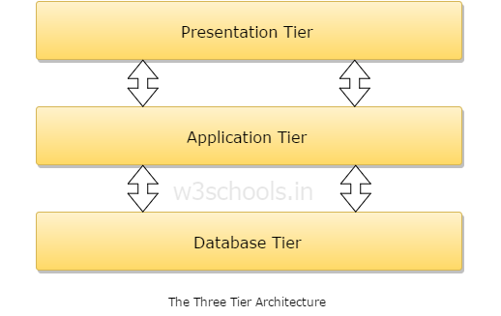

**Presentation Layer:**

Presentation layer is also known as Client layer. Top most layer of application . This is layer we see when we use a softwere.By using this layer we can accsees the webpages. The main functionality of this layer is to communicate with application layer. This layer passes the information which is given by the user in terms of keyboard actions, mouse clicks to the application layer.

**Application Layer:**

Application layer is also known as Business logic Layer . application layer interacts with the Data base layer and sends required information to the presentation layer. This layer acts as a mediator between the Presentation layer and Database Layer.

**Data layer:-**

The data is sorted in Data Layar .Application Layer communicates with Database layer to retrieve the data.

**There is three type of architecture based on the three layers:-**

* **1 tier architecture:-**

Single Tier or 1-Tier Architecture:It is the simplest one as it is equivalent to running the application on the personal computer. All of the required components for an application to run are on a single application or server.

Presentation layer, Business logic layer, and data layer are all located on a single machine.

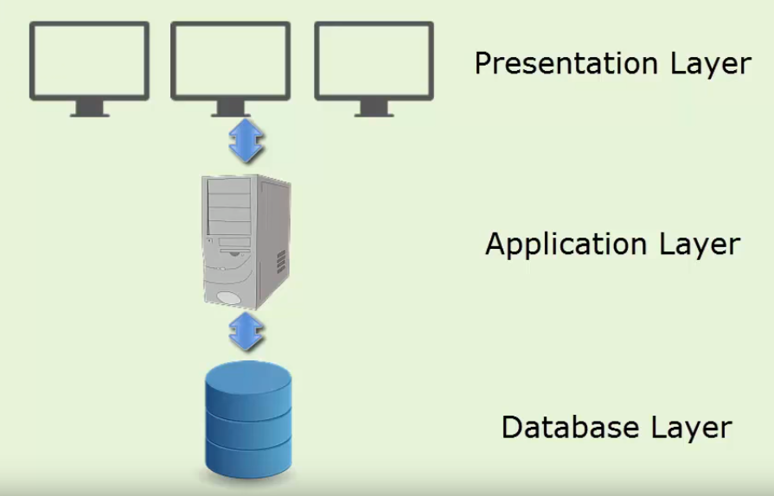

* **2 tier architecture:-**

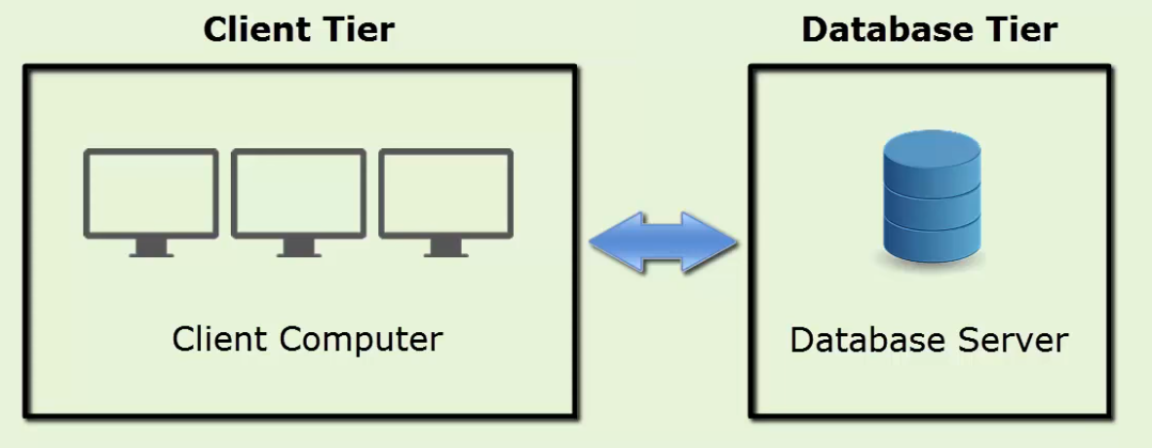It is like Client-Server architecture, where communication takes place between client and server.In this type of software architecture, the presentation layer or user interface layer runs on the client side while dataset layer gets executed and stored on server side.

* **3 tier architecture:-**

The three tier architecture is divided into three parts presentation layer, application layer , and server. The presentation layer is in client system , the application server handles application layer and server system handles the database layer.

